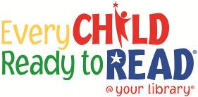

**STORYTELLING**

**This project funded in part through an Institute of Museum and Library**

**Services LSTA grant awarded by the State Library of Ohio**

**Storytelling is the ability to describe things and events and to create tales. This skill is important for reading development because it enables children to understand and explain the meaning of what they’re reading.**

**Narrative**

**Skills**