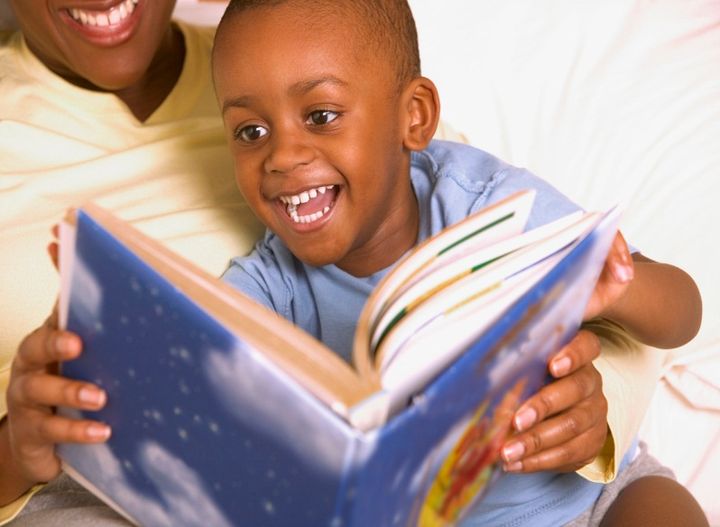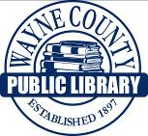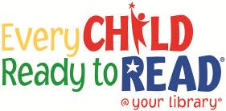

**LOVING BOOKS**

**This project funded in part through an Institute of Museum and Library**

**Services LSTA grant awarded by the State Library of Ohio**

**Print**

**Motivation**

**Loving books means being interested in and enjoying books. A child who loves books enjoys being read to, plays with books, pretends to write, and likes trips to the library.**