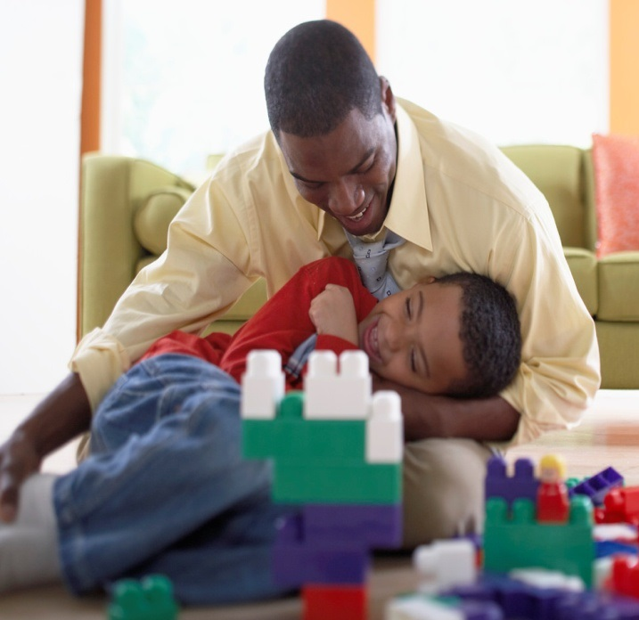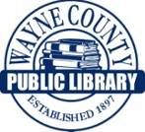

**Play is one of the main ways young children learn about the world. General knowledge is an important literacy skill that helps children**

**understand books and stories**

**once they begin to read.**

**Playing helps children learn all of the six early literacy skills: letter knowledge, phonological awareness, narrative skills, print awareness, print motivation and vocabulary.**

**This project funded in part through an Institute of Museum and Library**

**Services LSTA grant awarded by the State Library of Ohio**



**Reading together, or shared reading, remains the single most effective way to help children**

**become better readers.**

**This project funded in part through an Institute of Museum and Library**

**Services LSTA grant awarded by the State Library of Ohio**

**Reading helps children learn all of the six pre-literacy skills: print awareness, print motivation, letter knowledge, narrative skills, phonological awareness, and vocabulary.**

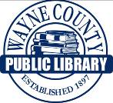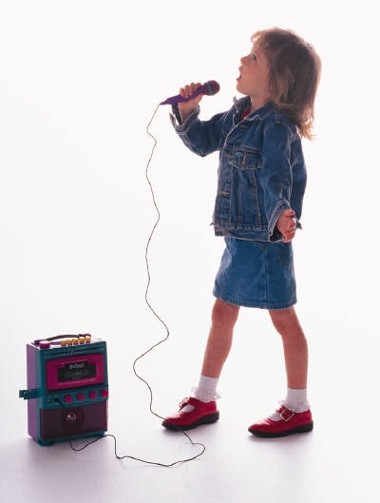

**Singing helps children learn three of the six early literacy skills: letter knowledge, phonological awareness, and vocabulary.**

**This project funded in part through an Institute of Museum and Library**

**Services LSTA grant awarded by the State Library of Ohio**

**Singing, which also includes rhyming, increases children’s understanding and observance of the sounds in words. This helps children to**

**translate print (written language).**



**This project funded in part through an Institute of Museum and Library**

**Services LSTA grant awarded by the State Library of Ohio**

**Talking helps children learn all of the six early literacy skills: print awareness, print motivation, letter knowledge, narrative skills, phonological awareness, and vocabulary.**

**Talking with children helps them learn oral language, one of the most**

**important early literacy skills. The experience of self-expression also stimulates brain development, which is the foundation for all learning.**

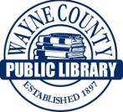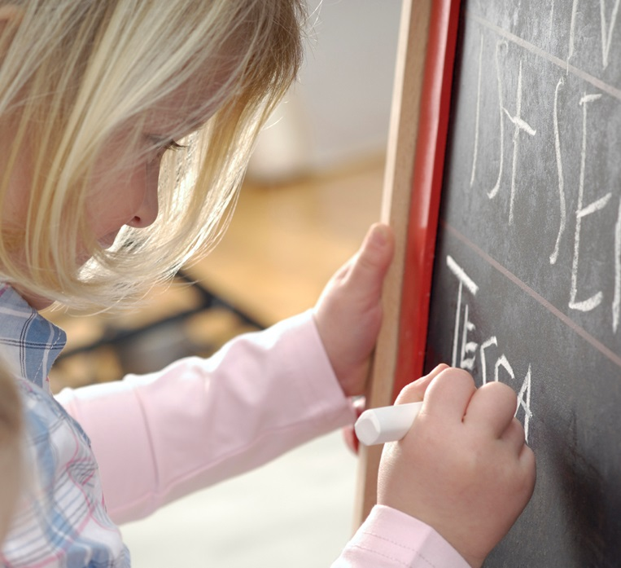

**This project funded in part through an Institute of Museum and Library**

**Services LSTA grant awarded by the State Library of Ohio**

**Writing and reading go**

**together. Writing helps**

**children learn that letters and words stand for sounds and that print has meaning.**

**Writing helps children learn all of the six early literacy skills: letter knowledge, phonological awareness, narrative skills, print awareness, print motivation and vocabulary.**